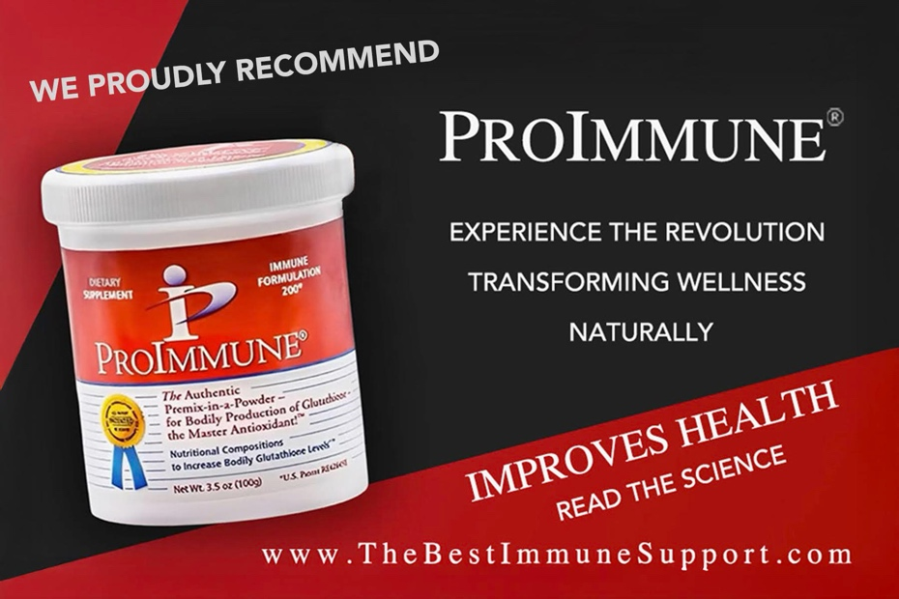

Groundbreaking Clinical, Scientific & Global Regulatory Milestones
- NIH-Funded Research by 18 Major Universities
ProImmune was the subject of extensive evaluation under an $88 million NIH grant, involving 18 leading U.S. universities. Across multiple peer-reviewed studies, ProImmune was found to be more effective and efficient than glutathione any molecule or N-acetyl cysteine (NAC) in boosting immune function, cellular detoxification, and antioxidant protection. Also perfect for intracellularly detoxing of microplastics, heavy metals and glyphosate to support optimal cell function. ProImmune also reduces oxidative stress and inflammation.
Improves CKD More Effectively than Glutathione or NAC
NIH-supported peer reviewed findings also demonstrated that ProImmune offers superior outcomes in managing oxidative stress and improving markers of chronic kidney disease (CKD) surpassing both NAC and glutathione in safety and cellular effectiveness.
- Approved in 37 Countries as a Natural Statin Alternative
ProImmune has been approved in 37 countries as a natural alternative to statins, safely modulating cholesterol and supporting cardiovascular health without the side effects associated with pharmaceutical statins making it ideal for integrative protocols focused on metabolic balance. Many physicians have witnessed patients lower cholesterol and A1C levels all naturally and be able to reduce or eliminate toxic statin medications.
- Phase I & II Clinical Trial – Rwanda (NCT04742725)
A government-approved human trial during the height of the COVID-19 pandemic enrolled 250 participants, confirming no side effects and demonstrating reduction in SARS-CoV-2 and HIV viral loads via PCR. This real-world data confirms both safety and therapeutic potential as an all-natural antiviral.
- CARES Act Deployment – Essential Workers, North Dakota
During the COVID-19 pandemic, ProImmune was deployed under the CARES Act to essential truck drivers at Schmidt Liquid Trucking. Supervised by Dr. Ted Fogarty, drivers received high daily doses (3.3g/day) with zero adverse effects and 100% workforce retention. In 2020, ProImmune was approved as a Covid-19 Countermeasure before vaccines were available. Dr. Edward Fogarty later published a case study in Frontiers of Neurology showing that ProImmune, combined with hyperbaric therapy, reversed dementia.
ProImmune’s patented technology activates natural intracellular glutathione synthesis unlike glutathione or NAC, which are less potent and may cause side effects. ProImmune enables cells to produce glutathione directly inside cells where it’s needed, supporting detoxification, reducing oxidative stress, and boosting immune resilience. Discovered and developed over ten years of research by Dr. Albert B. Crum, M.D., DSc, (Hon), M.S., this breakthrough precursor is being compared to the discovery of penicillin and insulin. According to Dr. Judy Mikovits, PhD in molecular biology & biochemistry, it is a one-of-a-kind glutathione precursor, unrivaled by any molecule that cannot effectively or efficiently cross the cell membrane.
The # 1 Health Formula Sweeping Across America
TheBestImmuneSupport.com
Benefits of ProImmune Immune Formulation 200
ProImmune is designed to support immune health and overall wellness, offering several features that may set it apart from other supplement products. Here are some of its key attributes:
Nutrition that strengthens the immune system, enhancing defense against invaders.
- Detoxification: Helps removes toxins inside the cells and from the body, promoting overall health.
- Aids in nutritional tissue repair and regeneration.
- Reduces oxidative stress and helps with natural inflammation responses.
- Skin health combating oxidative damage and supporting collagen production.
- Supports energy production at the cellular level, reducing feelings of fatigue and enhanced vitality.
- Optimizes cognitive function and mental clarity.
- Supports liver function by aiding in detoxification processes.
More about the Immune Formulation 200:
- NrF2 gene activation which produces antioxidant enzymes and proteins that help the body combat oxidative stress and healthy inflammation, thereby promoting cellular health.
- Exclusive formula, unmatched by any other company, stands as a revolutionary breakthrough in health and wellness.
- Facilitates natural glutathione production within the body’s cells.
- Supplements cells to naturally produce glutathione in accordance with natural processes.
- Received Federal CARES Act funding and approval as a Covid-19 Countermeasure.
- Glutathione: Essential antioxidant, helps immunity, detoxifies, aids in natural tissue repair, and enhances overall health, energy, mental clarity, and natural detoxification processes.
- Modern pollutants and processed foods that contain toxicity deplete glutathione, emphasizing the importance of replenishing glutathione directly inside of cells.

- Natural Glutathione Production: ProImmune utilizes the body’s natural processes to produce glutathione, which may provide a more sustainable approach to managing oxidative stress and inflammation responses compared to other supplement nutrient options. ProImmune synthesizes glutathione intracellularly directly inside cells providing effective results.
- Immune System Support: By supplementing factors that can affect immune function, ProImmune may help maintain a healthy immune response, potentially aiding the body in managing damage and recovery.
- Detoxification: Glutathione is involved in detoxifying the body and supporting liver function by helping to eliminate harmful substances.

- Inflammation Response: By targeting natural inflammation response at the cellular level, ProImmune can contribute to overall health by providing optimized nutrition reducing the risk of issues associated with daily stresses and inflammation.

- Research Support: ProImmune has been backed by peer-reviewed research and federal CARES Act funding, which support its credibility as a natural option for supporting immune health.

A Healthier Safe Alternative to A Non-Natural Approach – TheBestImmuneSupport.com
Many immune support products available today, such as glutathione and the precursor-NAC do not offer the same level of long-term effectiveness as natural solutions like ProImmune supplementation. While NAC purports to provide glutathione precursors on a laboratory benchtop setting, it does not utilize the body’s natural ability to produce glutathione within the cell only where and when it is needed. ProImmune’s formulation takes a different natural approach by working directly with the body’s processes inside the cells, leading to more efficient supplementation. If you are interested; Charles Drew University of Medicine and Science evaluated ProImmune performance compared to NAC glutathione precursor. You can find that article on the world-wide web or on TheBestImmuneSupport.com website in the science section. The unique combination of amino acids and mineral cofactor in ProImmune Immune Formulation 200 supports not only immune function but also cellular repair and detoxification.* This comprehensive approach makes it a superior option for those looking to meet their overall health goals as efficiently as possible.* Developed by Dr. Albert B. Crum, an expert in immunology and biochemistry, ProImmune Immune Formulation 200 is based on extensive research into in vivo glutathione synthesis and its role in human health. The product features a patented formulation designed to support the body’s natural ability to produce glutathione, which may contribute to immune response, help manage oxidative stress and promote overall wellness.*ProImmune’s development has garnered attention from both the scientific and clinical communities, with endorsements from renowned doctors and healthcare professionals. The product’s unique approach to supplementing cellular health has made it a preferred choice for those seeking safe, long-term practice to maintaining immune health.

For further Information or To Order ProImmune Contact: info@TheBestImmuneSupport.com
Instagram: Best Immune Support
Call or TEXT Joseph V Cassarino at: 845-206-8104

